**Group Final Project Report <Group 1 >**

Group project : Great Travel Agency web site

Members : Luk Ka Chun Steven (10),

Wong Ka Fai (24),

Law Pui Ming Peter (25)

**Introduction**

Due to we have a web site for travel agency at Frontend Web Developer, so we decided to follow the past web site as our final group project for backend web developer group final project.

System installation, setup and access, please follow the following steps:

1. Find the folder “finalproject”, which inside of the Group 1 10_24_25 Final project folder, then copy to one device which installed mongodb.
2. Install Visual studio code with related modules as show below, normally, the related modules had been installed and store in the final project folder.

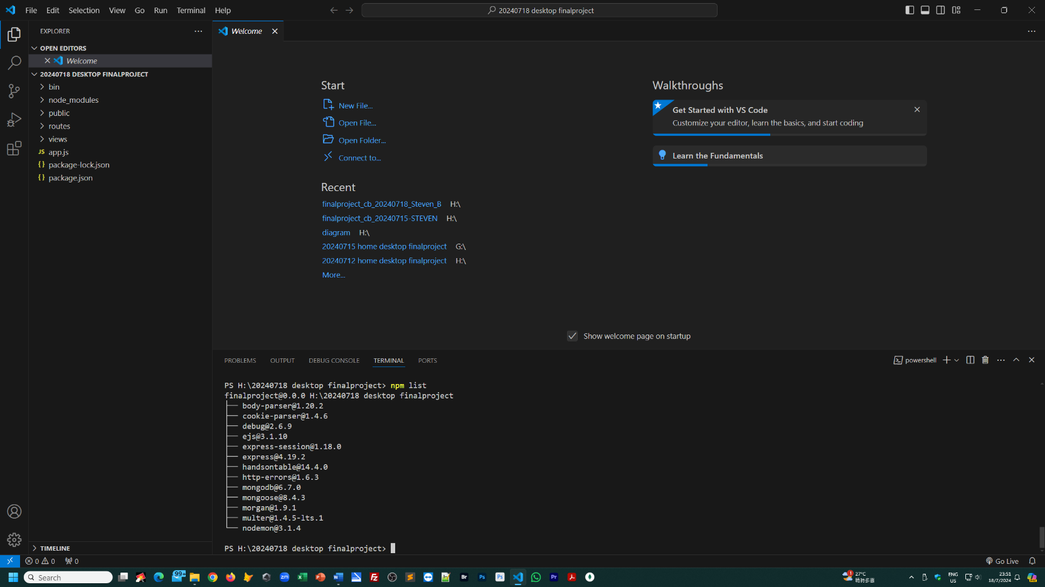

1. Open Visual studio code and open folder “finalproject”.
2. type the “npm run monstart” at terminal.
3. import mongodb collection which inside of Group 1 10-24-25 Final project folder, or setup mongodb database collections from your browse, input these URL to build up mongodb datbases collection.

127.0.0.1:3000/db/createcompany

127.0.0.1:3000/db/createcontactus

127.0.0.1:3000/db/createenduser

127.0.0.1:3000/db/createmember

127.0.0.1:3000/db/createpackage

127.0.0.1:3000/db/createsubscribe

127.0.0.1:3000/db/createsysoperator

127.0.0.1:3000/db/createtestimonial

1. at this stage, you can input the following URL at the browse to visit the frontend and backend, and the valid login id and password as below;

Frontend – 127.0.0.1:3000

Member Login id – [annachan@gmail.com](mailto:annachan@gmail.com)

Password – 12345678

Backend – 127.0.0.1:3000/CMSAdminLogin.html

Login id – Admin

Password - 12345678

**Brief of Great Travel Agency website**

Site map

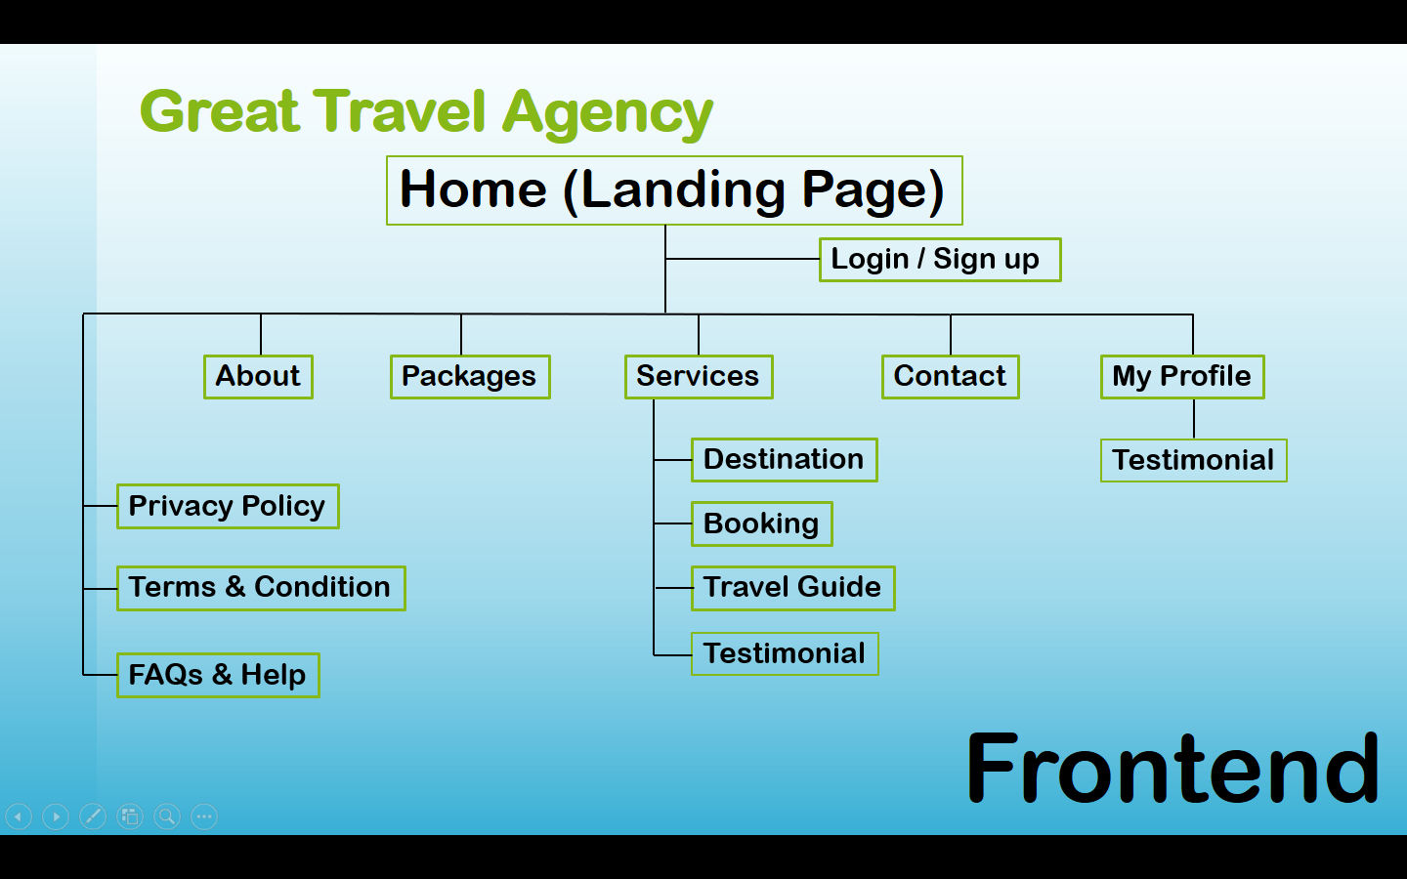

**Landing page**

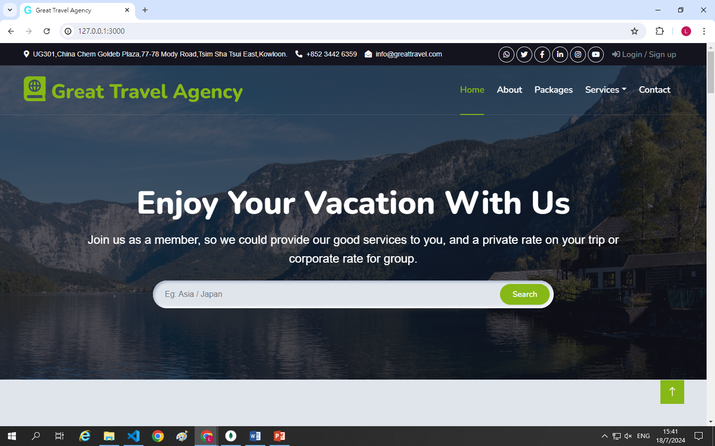

In this landing page, it has a login/sign up button for the visitor to login into the system or join as a member. The member data is stored in the database of member.

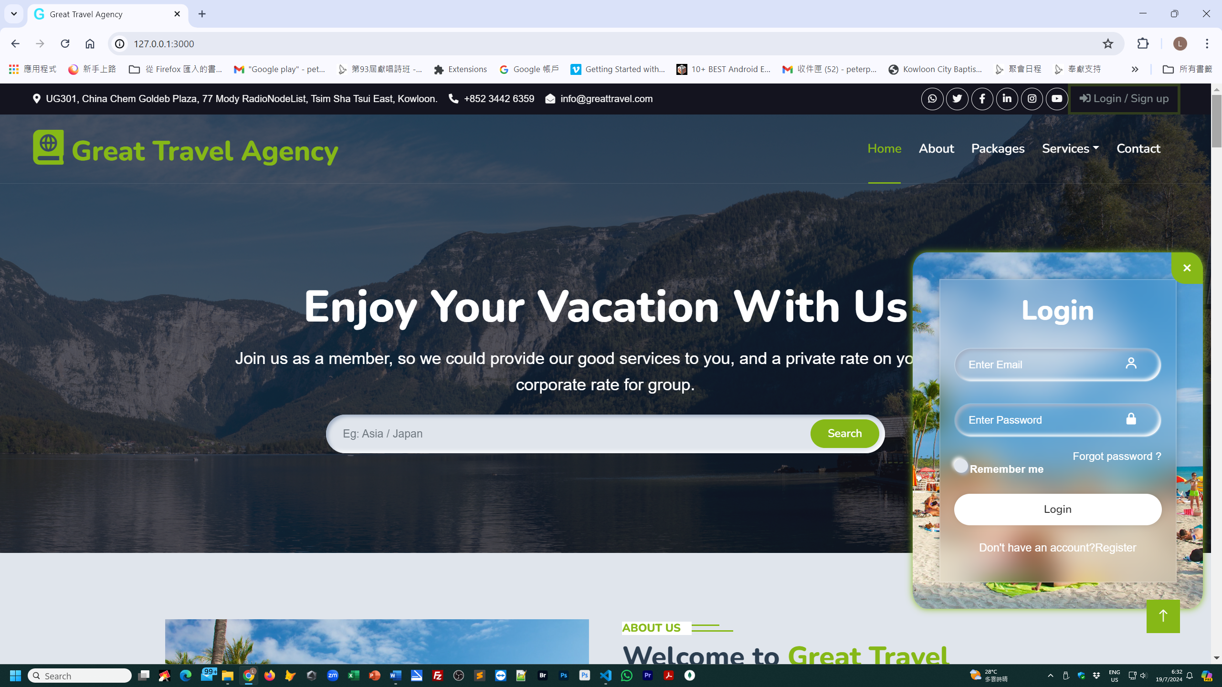

For the member, it has a member profile to collect the basic information of member, such as the full name or nick name which will show on screen, and the favorite travel information for the analysis and promotion.

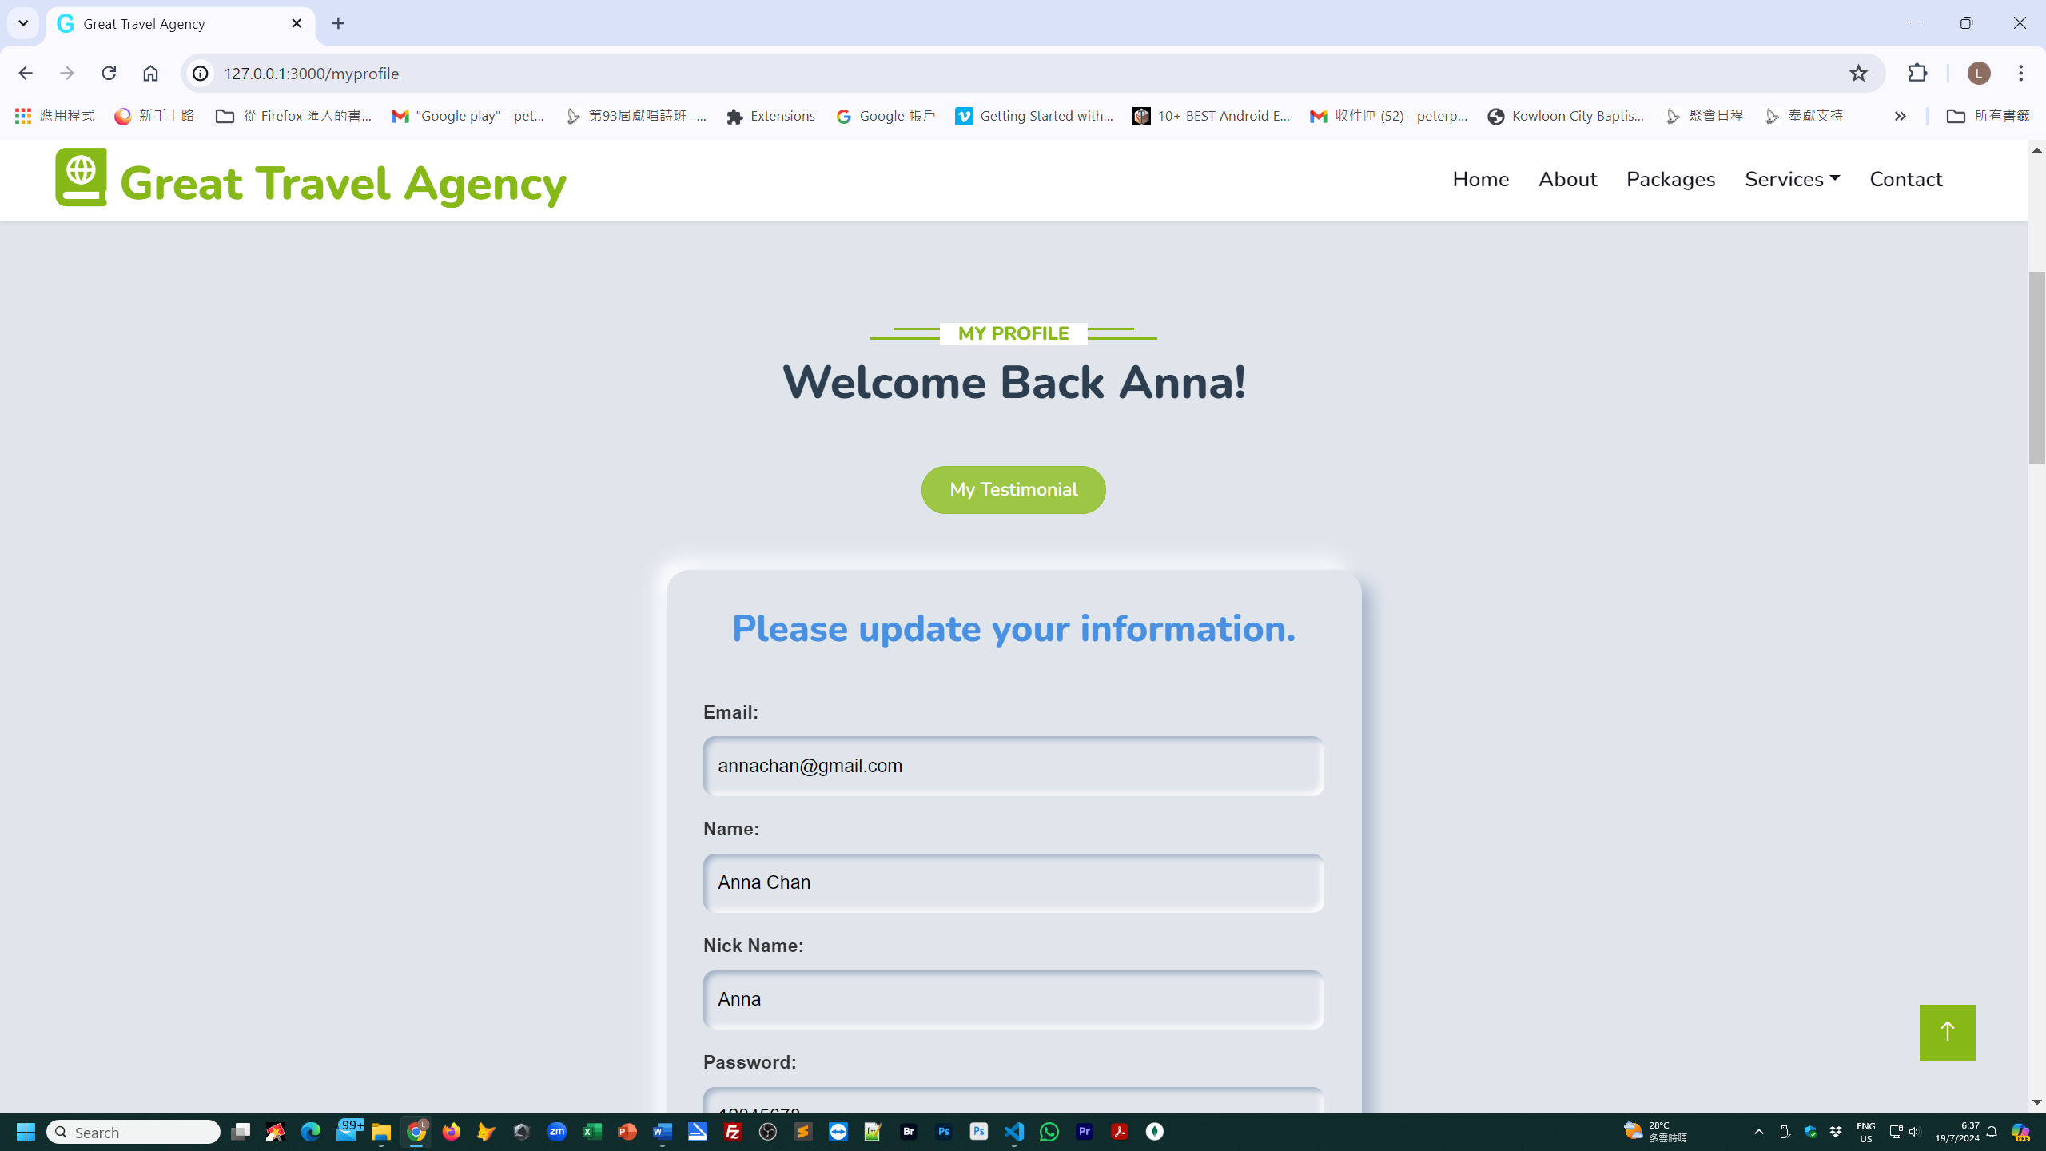

System provides a testimonial for the member to input their comment, the testimonial will show on the front end.

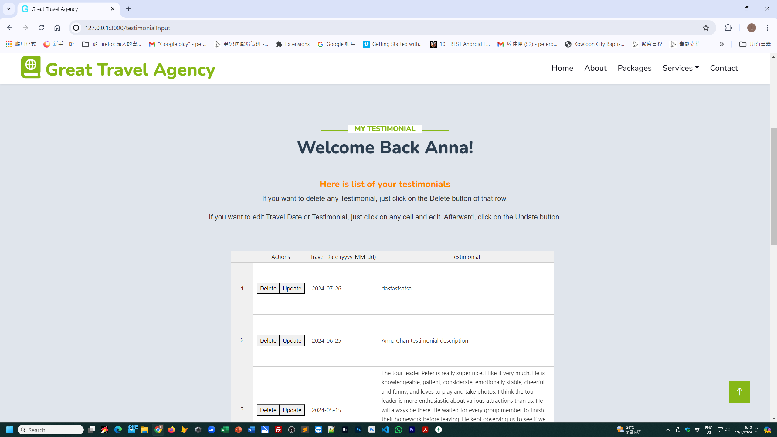

In this website, under the ***Home*** page, there are 4 pages. They are ***About***, ***Packages***, ***Services***, ***Contact***.

From the ***About*** page, customers can get the background information of company.

Under the ***Packages*** page, it provide several awesome packages for customers. There is a page “Online Booking” for customers to fill in the following information of their preferred trips :

* Your name
* Your Email
* Date & time
* Destination
* Special Request

Once they fill in the relevant information, the staff of the travel agency will contact them to follow-up.

Under the ***Services*** page, there are 4 pages. They are ***Destination***, ***Booking***, ***Travel Guide*** and ***Testimonial***.

In the ***Destination*** page, there are beautiful photos of our recommended places. After becoming our members, customers can get discounts on joining our trips.

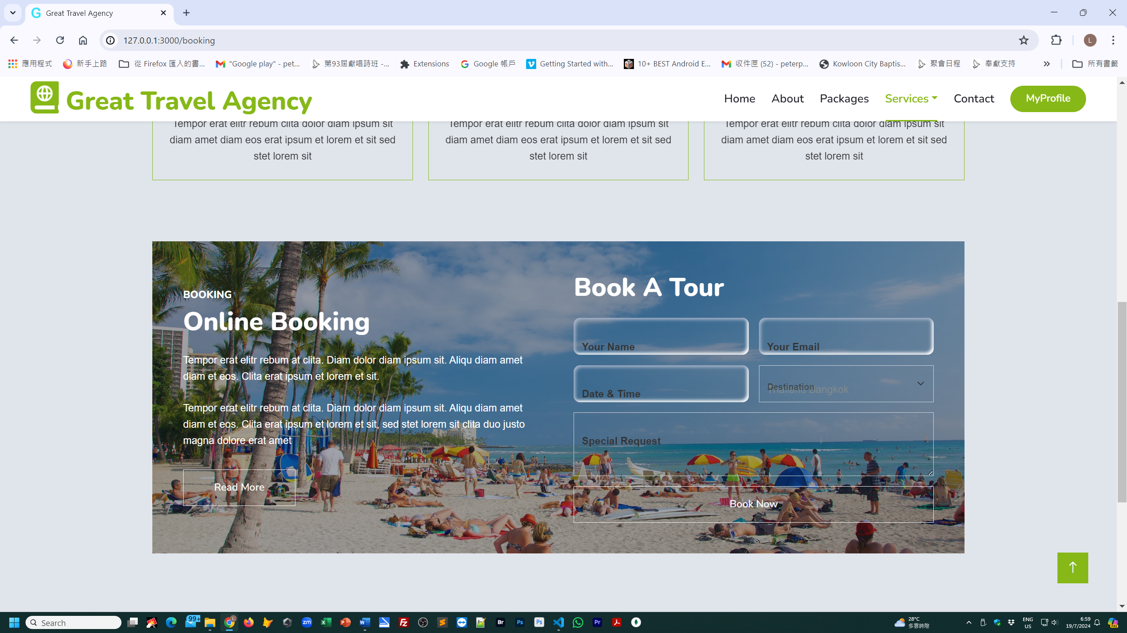

Under the ***Booking*** page, the “Online Booking” screen will be popped up for the customers to fill in relevant information.

Under the ***Travel Guide*** page, the photos of our travel guides are provided.

In the ***Testimonial*** page, the commendations from our previous customers are posted.

In the ***Contact*** page, the background information of our company is provided.

Under the ***Register*** page, there is a form for our customers to fill in their personal information and their favorite cities and countries for travel and mode of transportation. Such information can facilitate our planning of recommended trips for our customers.

For formalities, pages of ***Privacy Policy*** and ***Terms & Condition*** are contained in the website. The last page is ***FAQs & Help***.

We have applied the application of HTML、CSS、JavaScript and Bootstrap, Nodejs, API and Mongodb to constructing our website.

Our website base colour is “#86B817”. Google fonts (Nunito, Sans-serif, Heebo), Icon fonts are applied. Social media such as Whatsapp, Twitter, Facebook, Linkedin, Instagram and Youtube are provided in the website to facilitate our customers to contact us.

On the backend, the system has administrator to handle the frontend and backend of web site. It has a CMS web page.

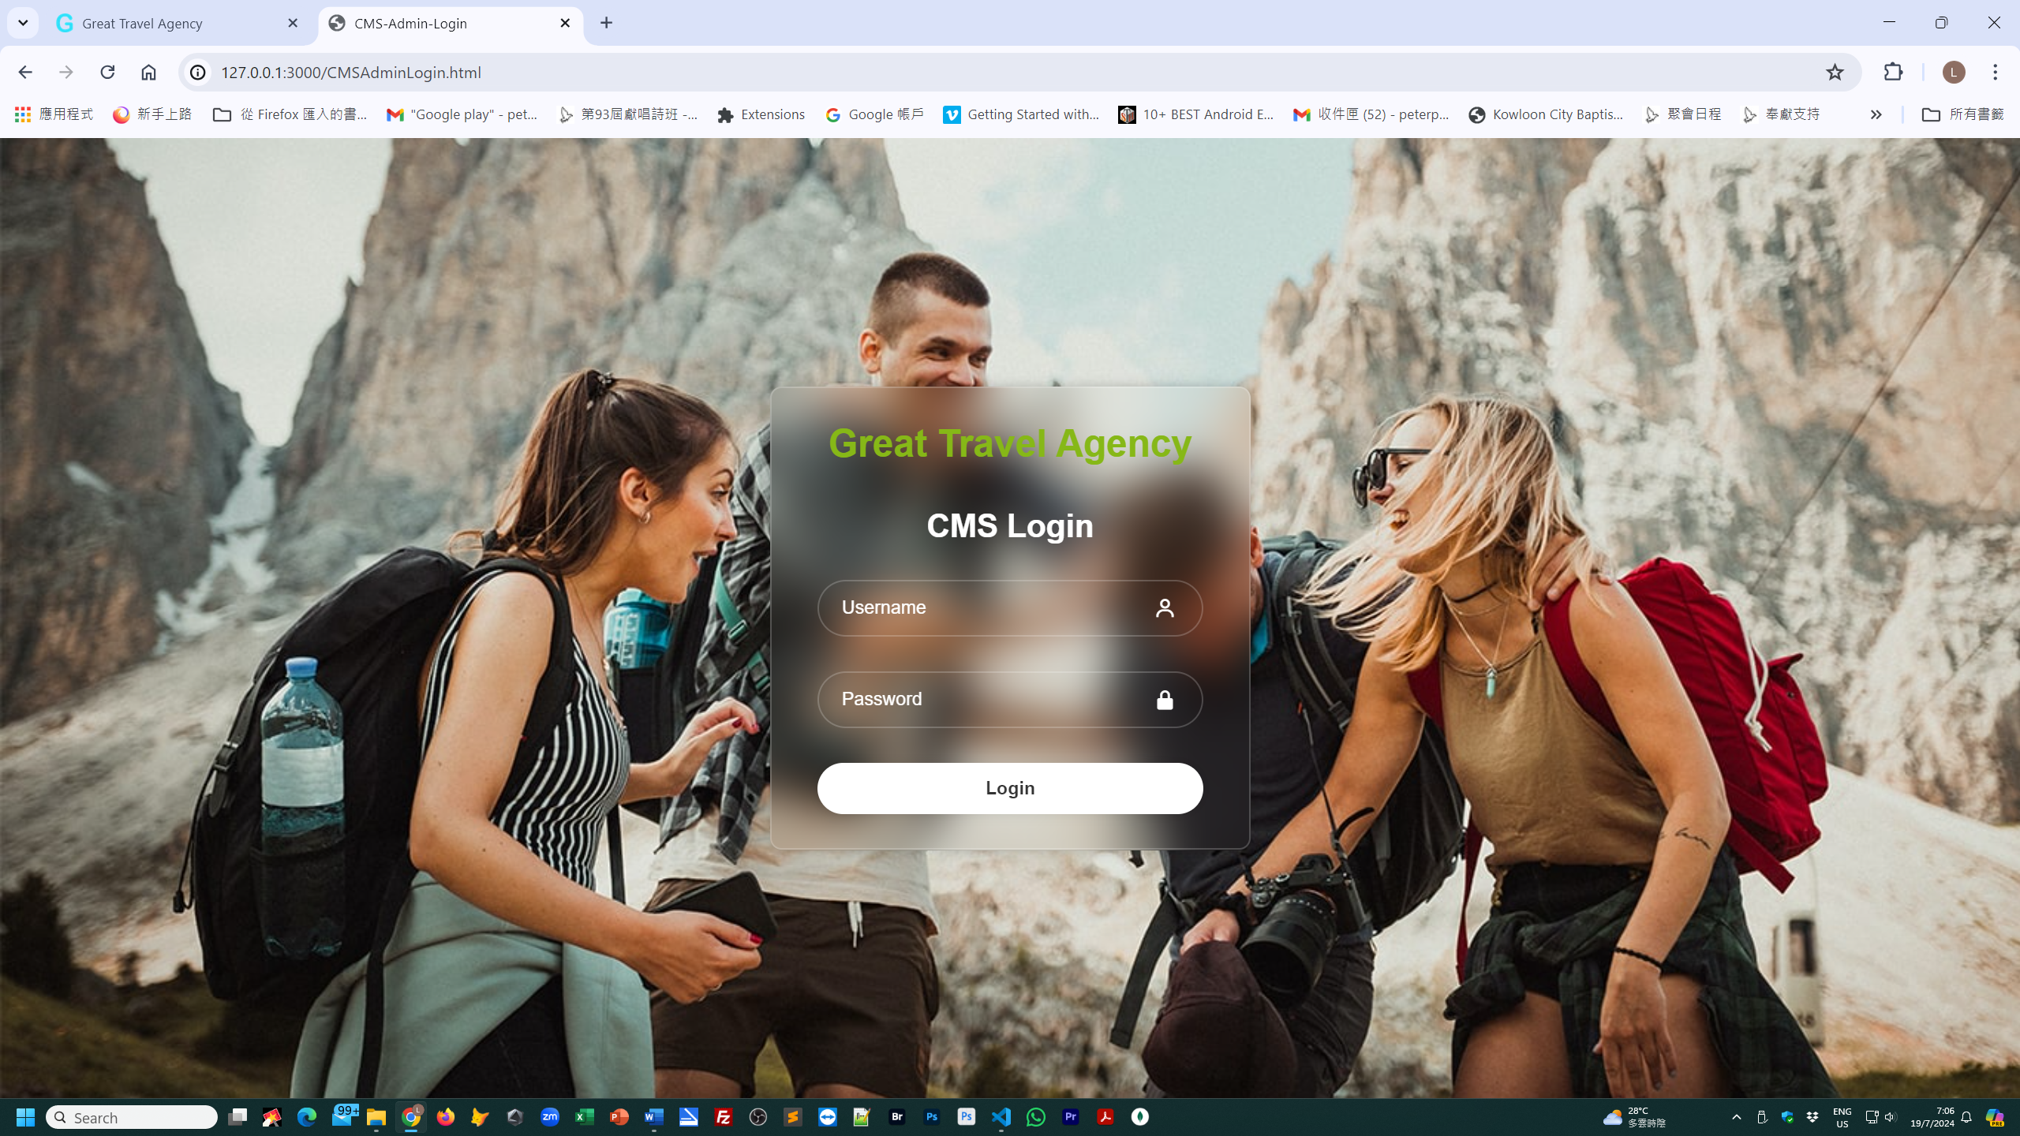

At the dashboard menu, administrator can maintain the database, such as create, read, update or delete.

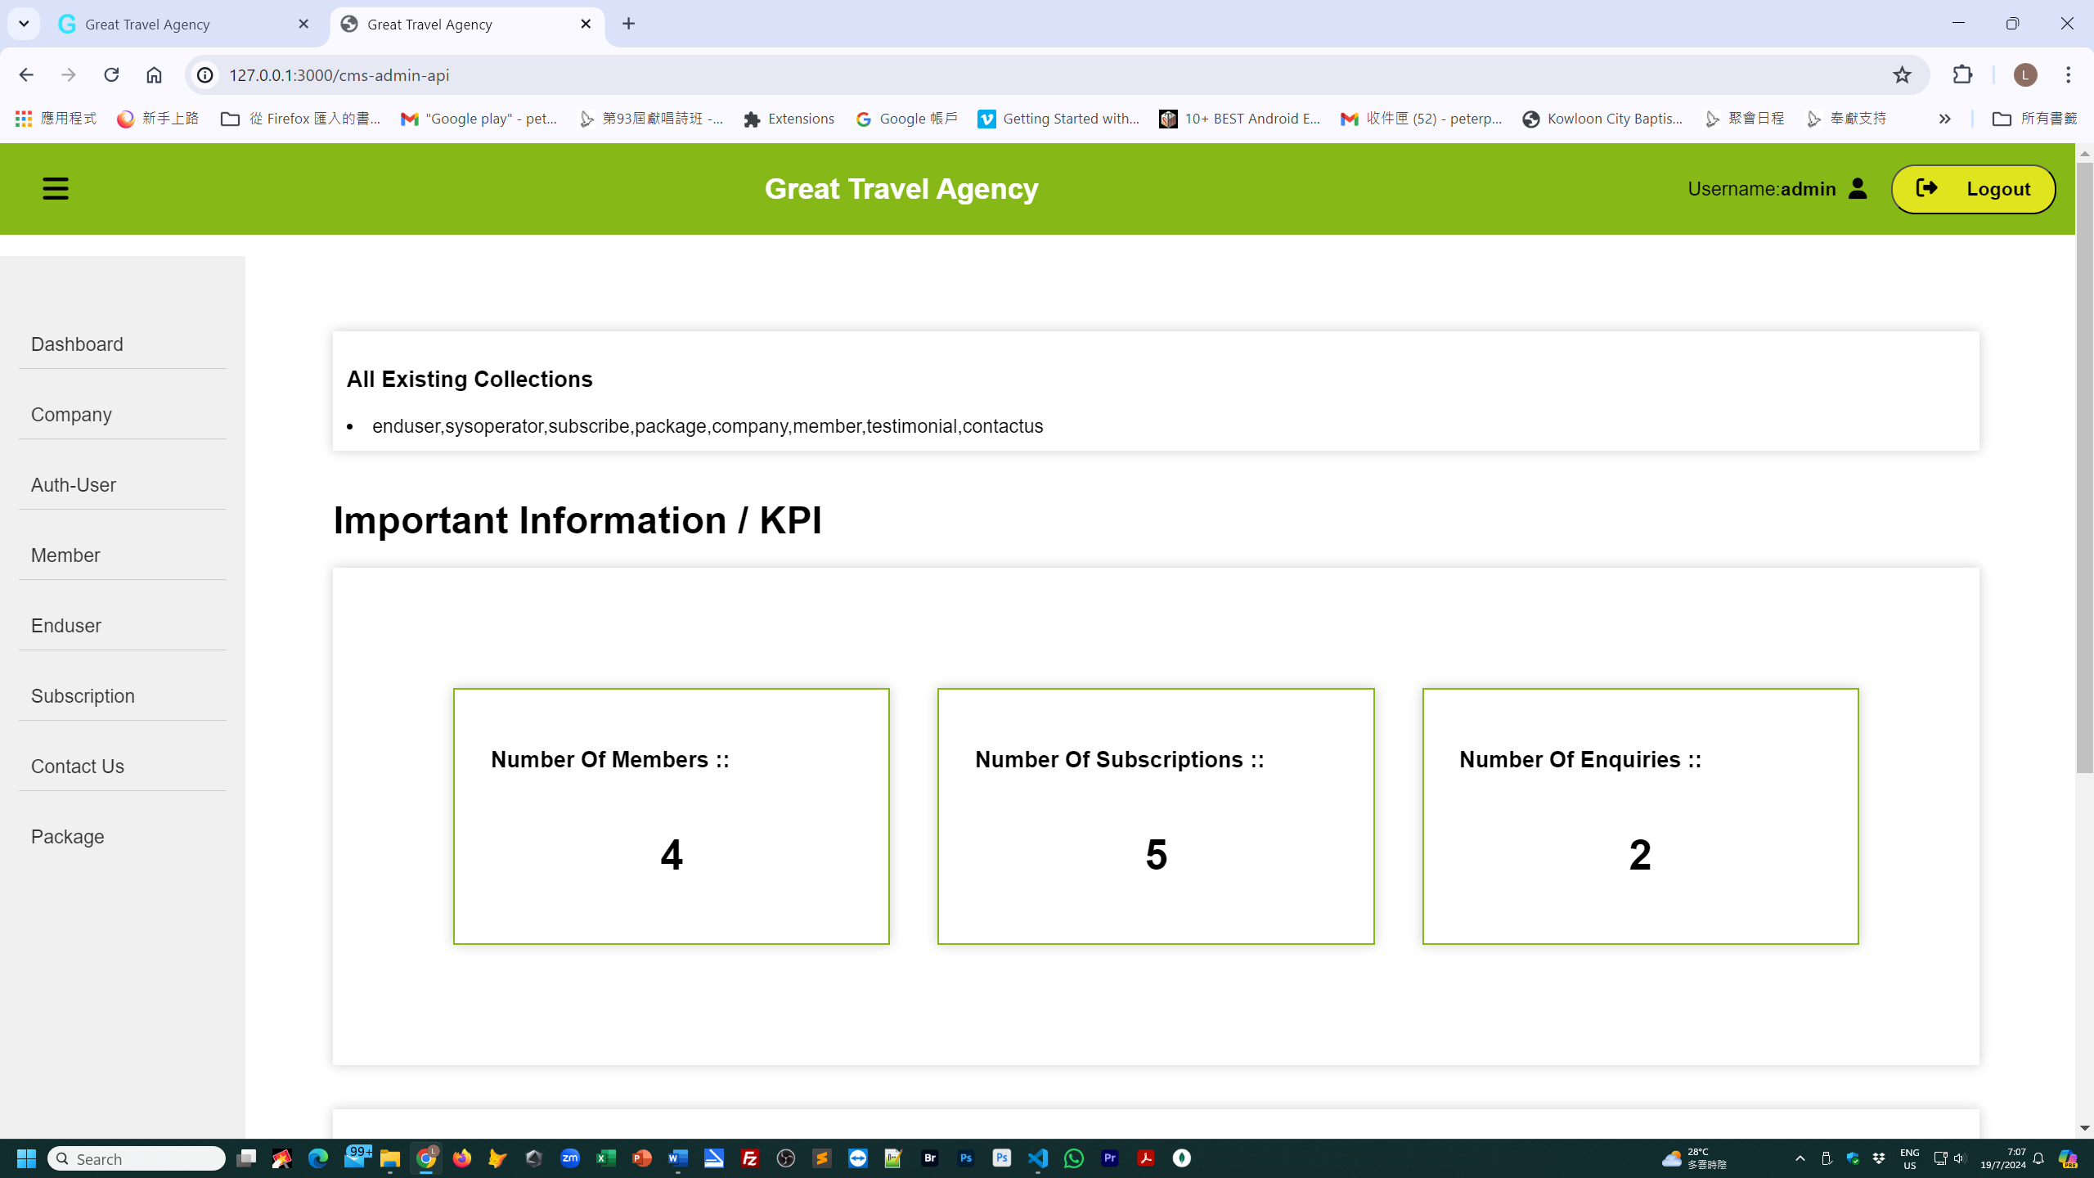

At this stage, system has mongodb database to maintain the web site.

|  |  |
| --- | --- |
| **Collection** | **Description** |
| Company | basic information of Great Travel Agency |
| Enduser | the staff of Great Travel Agency, such as the tour guide. |
| Contactus | visitors can contact us by email to inquire about the latest travel information. |
| Package | it contains detailed information of each travel package. |
| Subscribe | visitors can subscribe to the Great Travel newsletter. |
| Sysoperator | this is system administrator, supervisor, operator etc. |
| Member | the client of master |
| Testimonial | the client can give some comment after their trip. |